Name: Priyal T
Reg.No: 192324132

DSA0230-Computer Vision with OpenCV for Image Processing
Lab Experiments 1 - 5

1. Perform basic Image Handling and processing operations on the image.
a. Read an image in python and Convert the given Image into Grayscale
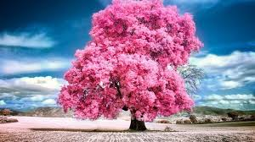
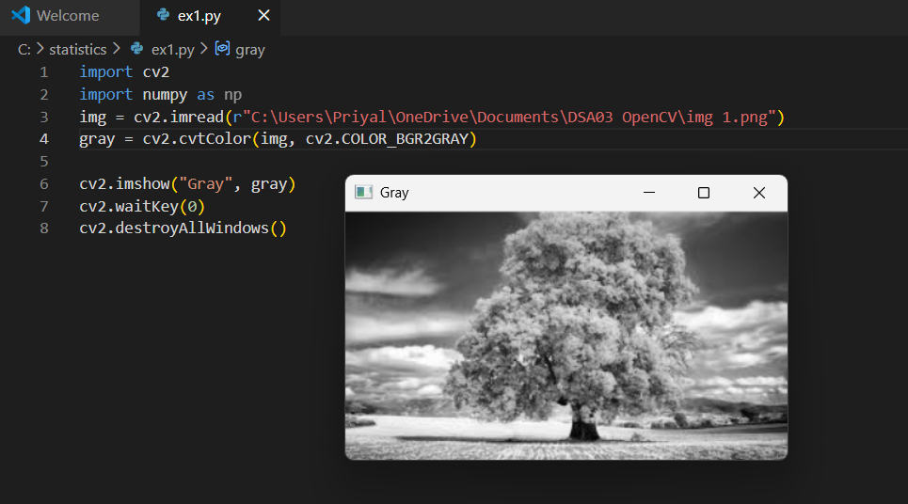

b. Read an image in python and Convert an Image to Blur using GaussianBlur.
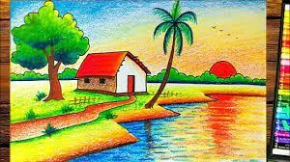
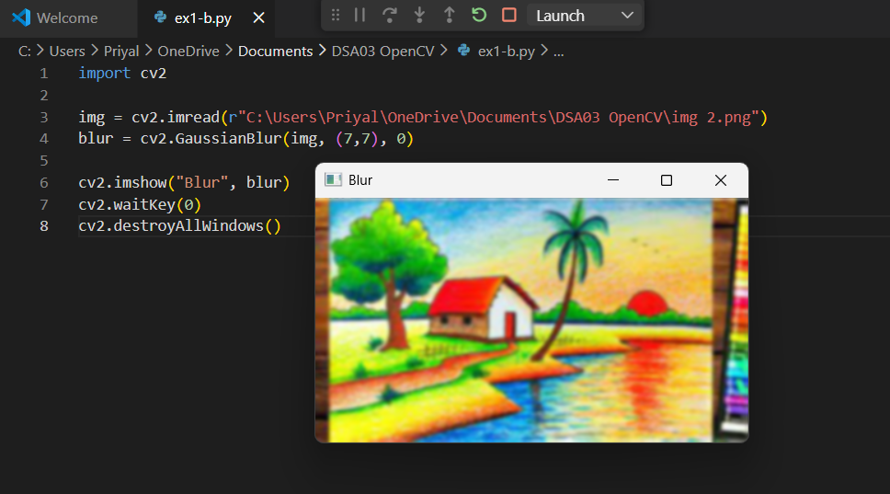

c. Read an image in python and Convert the given Image to show outline using Canny function.
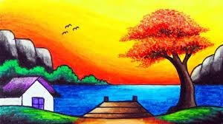
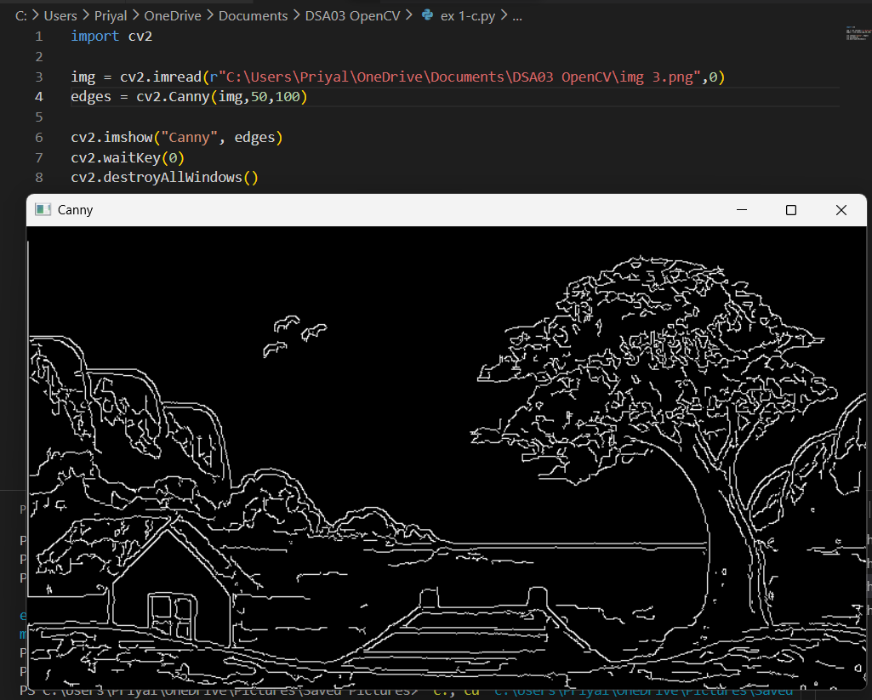

d. Read an image in python and Dilate an Image using Dilate function.
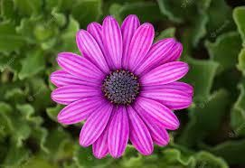
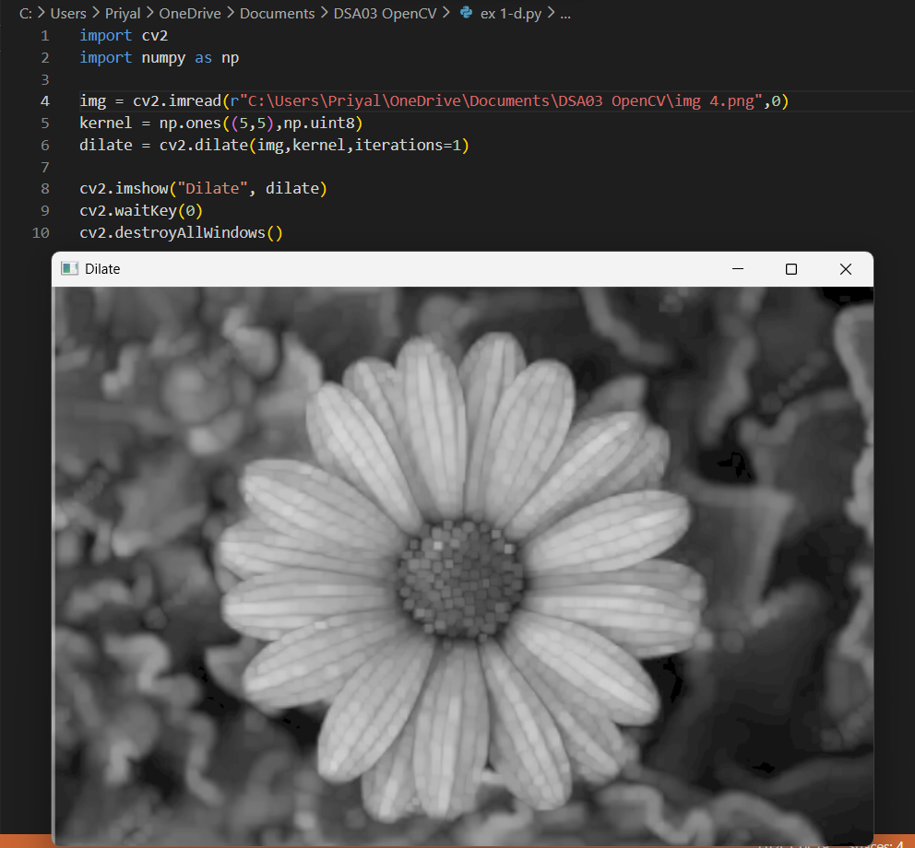

e. Read an image in python and Erode an Image using erode function.
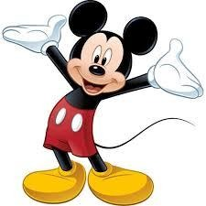
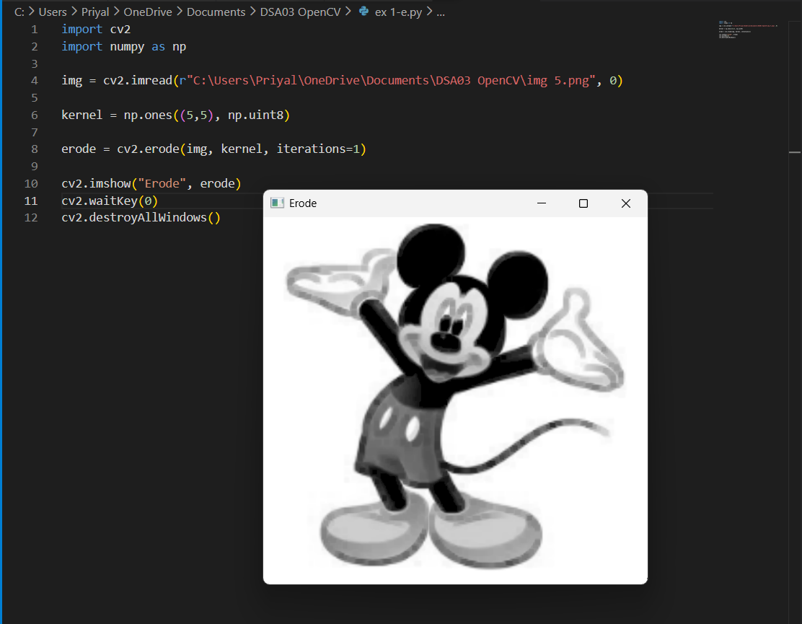

2. Perform basic video processing operations on the captured video
• Read captured video in python and display the video, in slow motion and in fast motion.
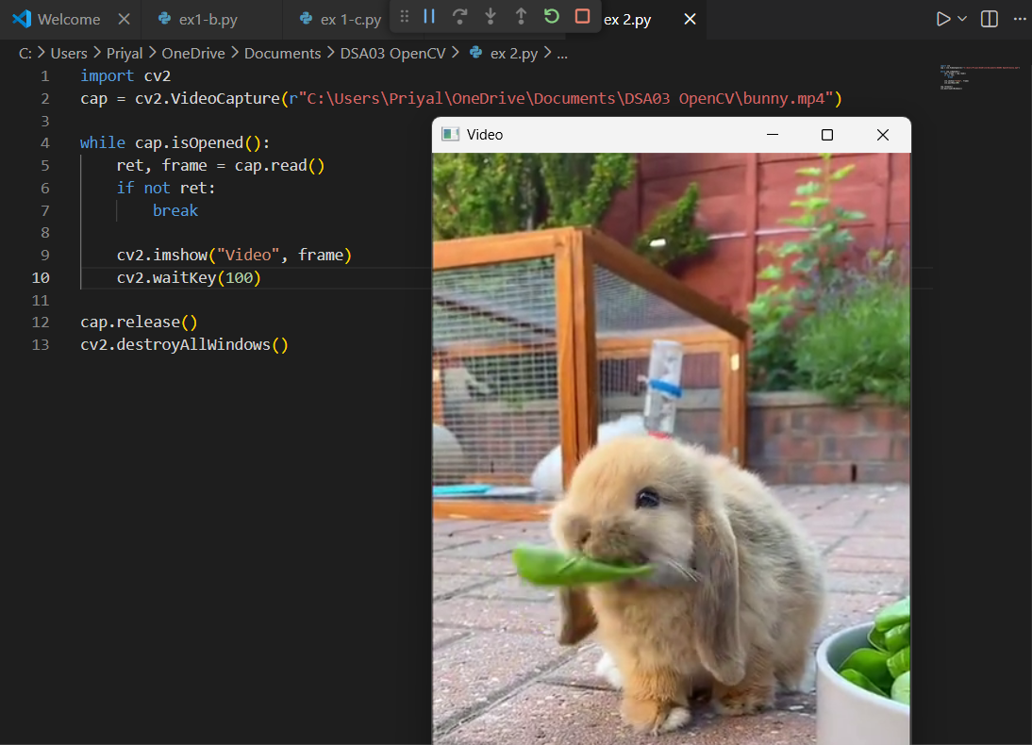

3. Capture video from web Camera and Display the video, in slow motion and in fast motion.
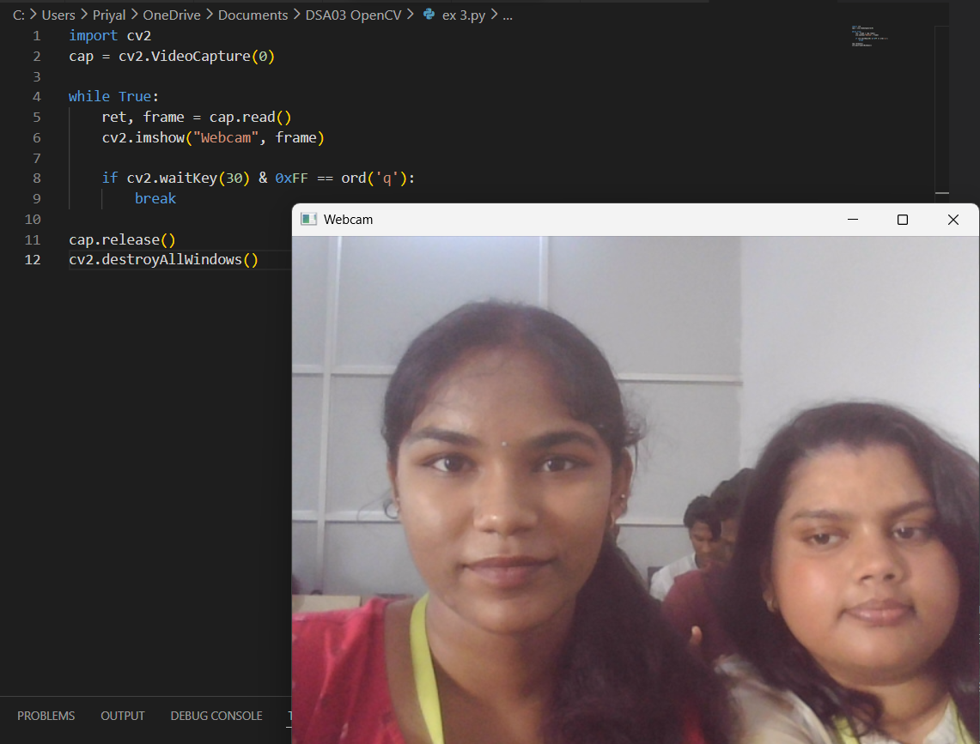

4. Scaling an image to its Bigger and Smaller sizes.
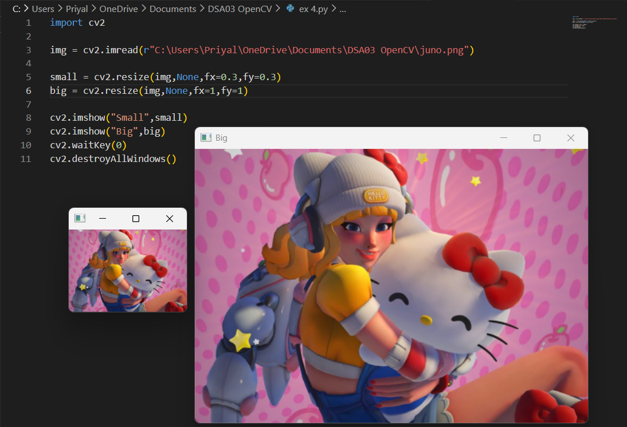

5. Perform Rotation of an image to clockwise and counter clockwise direction.
